Pig Activity : Created Files and put these under directory

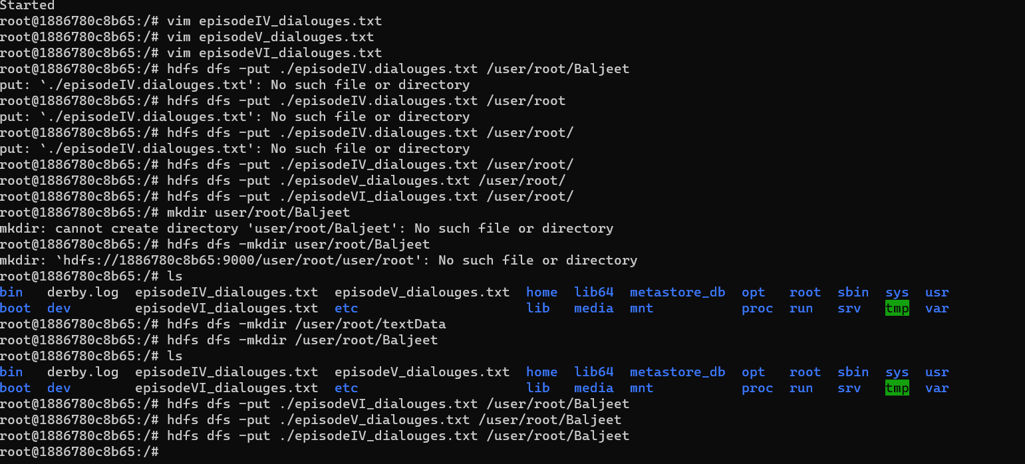

Create Pig File

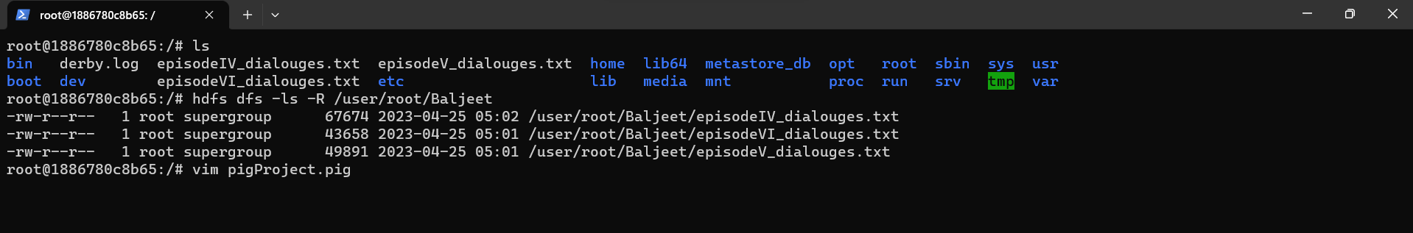

See contents of Pig file

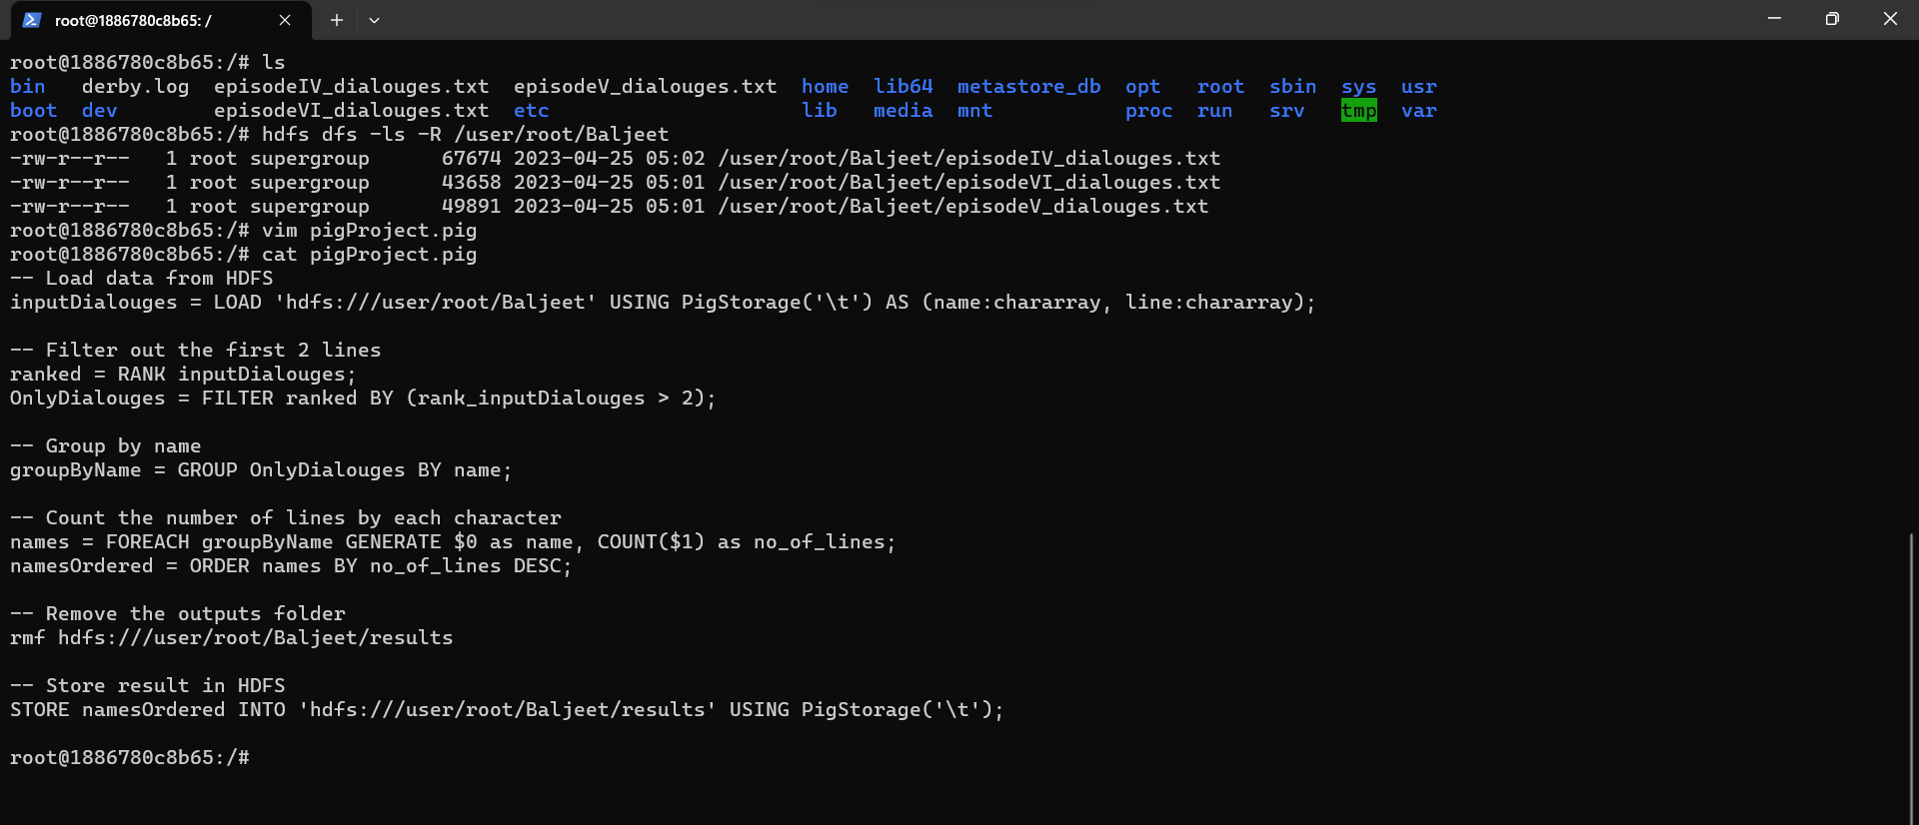

Pig script got completed

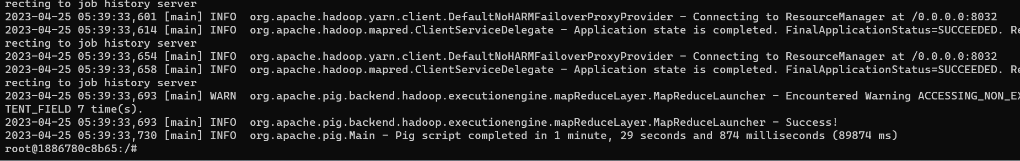

Results folder

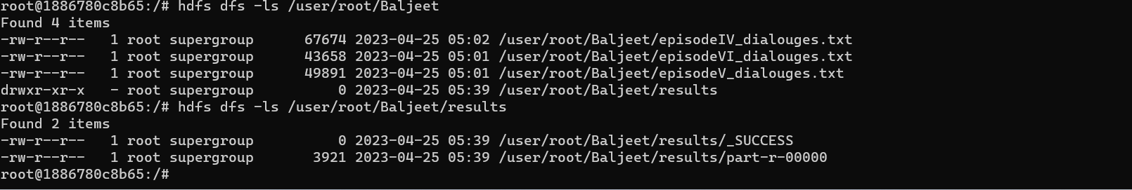

Result of episodes_dialouges in HDFS

